Effects of Ghrelin Administration in Chickens
Ostavia Cintron
Alabama A&M University
4/30/2019

Abstract
It is the desire for every producer to practice economic farming, which can lead to a profitable income. New scientific approach on poultry farming has recently increased production, as compared to the traditional methods of poultry production (Pomalégni et al., 2017). The scientific poultry farming requires farmers to ensure moderated intake of nutrients in their farms for efficient poultry production. Consequently, there is a need for regulating food intake by triggering and elevating levels of food consumptions in chickens, which in return results in fast growth. To be specific, Ghrelin which is generally viewed as a stomach hormone has been used in chickens to improve farm productivity. Ghrelin consist of 28 amino acid peptides. The 28-amino acid peptide can be described as an endogenous ligand, from an orphan G-protein coupled receptor (GPCR) leading it to be termed as a growth hormone secretagogue receptor (GHS-R); a synthetic compound with GH-production activity (Khatib et al., 2014). We conducted an experiment using a ghrelin agonist, known as Entyce in six birds. Entyce was giving orally every morning at 7:00 A.M. for five weeks. In those five weeks, we feed the birds from 7:00 A.M, 12:00 Noon, and 5:00 P.M. We weighed and recorded their feed intake before refilling, and after refilling. By recording their feed intake, we were able to calculate and analyze how much food they consumed. Attached below, is a picture on the structural composition in ghrelin.
Structural Composition of Ghrelin
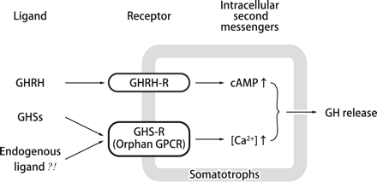
(Journal of Biochemistry, 2012 p.119-128)
Introduction
Ghrelin peptide consists of 28 amino acids, mostly in mammals that are responsible for food intake stimulations (Sobrino Crespo et al., 2014). On the other hand, GHS triggers the intracellular calcium ion located in the cells to exhibit receptors that are different from GHRH. GHRH is responsible for Camp accumulation. In particular; the ghrelin hormone secrets receptors (GHS-R) expressed in the hypothalamus, pituitary gland, and in the peripheral tissues (Yin, & Zhang, 2014). GHS is also expressed in the pituitary, hypothalamus, and peripheral tissues. GHS combines with GHS-R to produce GH. This peptide has an N-terminal that manifest a unique feature, due to the availability of the third amino acid contains a modified fatty acid (n-octanoic acid). Fatty acids play an indispensable role in the process of GHS-R binding, preparing it for the next peptide Activity (Bhattacharya et al., 2014). By studying the body structure in chickens, reveals a particular modification of ghrelin in their bodies. Ghrelin presents itself in a similar molecular shape in chicken confirming the possibility of the existence of GHS-R in most birds. Also, the presence of this molecule can be confirmed by segregating the peptide away from the chicken proventriculus.
In birds, ghrelin is different from mammalian species, in terms of amid acid numbers. Ghrelin in chickens consists of 26 amino acids, while mammals consisted of 28 amino acids (Tachibana, & Tsutsui, 2016). The differences in the numbers of amino acids occur; because there are fewer amino acids in chickens, when the presence of an n-octanoic fatty acid in ghrelin, and causes an acylation during the modification process. In chickens, the ghrelin gene contains four introns and five exons. (Takahashi et al., 2014). Despite that there are many exons in chicken ghrelin, only exon two and exon five are used during preproghrelin encoding.
Expression of mRNA and Peptide in Chicken
In chickens, the distribution of ghrelin mRNA contains large quantities in the upper part of the proventriculus, except for the gizzard. This procedure in all levels is monitored analytically using RT-PCR, which involves expressing the mRNA systematically from the brain down to the interstices in layer or boilers (Kitazawa et al., 2015). It should be noted that most of the ghrelin synthesis sites are typical for both layers and boiler, making mRNA manifest in the growing and hatching process. The mucosal layer stores ghrelin-ex and ghrelin-in cells. The hypothalamus in chickens contains small muscular parts that are: the corpus striatum, cerebellum, brainstem, and the optic lobes. These parts are where most of the operation of mRNA takes place. The feeding intake in chickens reflects on the levels of ghrelin in circulation, that is stored in ghrelin-ex and ghrelin-ip cells. Producers can easily influence their feeding habits by fostering agile development.
Functionality
In mammals, ghrelin functions as an orexigenic hormone. In fact, when ghrelin iss injected peripherally and centrall, it triggers appetite and increases feedd intake (Howick, Griffin, Cryan, & Schellekens, 2017). However, intracerebroventricular injection GHS, in neonatal chicks decreases feed intake, because orexigenic NPY does not link well together. The inability of the GHS to stimulate digestive tract which accelerates digestion inhibits the rate of feeding in neonatal chicks. Research has reported ghrelin agonist on food intake in chicken during central ghrelin administration; some revealed that ghrelin administration does not affect feed intake in the chicken while other experiment reported inhibition of food intake after one out of administering ghrelin (Sintubin, 2014). All the investigations done on central ghrelin revealed that intracerebroventricular administration of ghrelin is a food intake inhibitor. On the other hand, peripherally ghrelin administration in chickens triggers the release of GH that escalate appetite foster in food intake. However, the effect of a ghrelin agonist given as a oral lavage in chickens has not been evaluated. Therefore, the objective of this experiment, was to evaluate daily doses of Entyce in chickens. We will be administering entyce orally in six birds for five days, repeatedly for five weeks. We want to see if entyce will have an effect on the chicken’s appetite over time. Also, we will be using the SAS program to analyze our data.
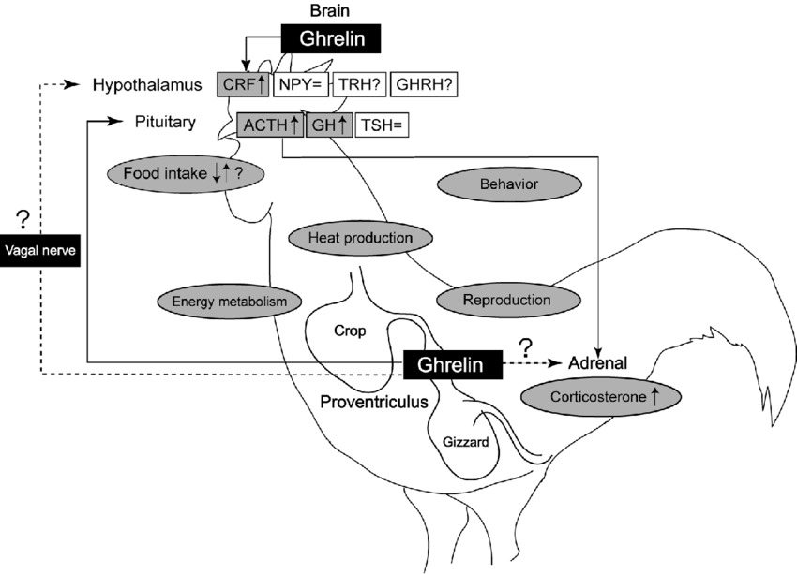
Figure 1: Ghrelin in birds

Materials
Materials used for this experiment were six birds, a scale, Entyce, feed, water, the SAS program, and a syringe.

Method
Starting on day 0 at 7:00 A.M., weigh and record feed intake before you refill. On experimental Day 1 (3 weeks of age), birds were randomly assigned to three treatments. Bidrs on Treatment 1 received 6mg/kg of BW of Entyce as an oral lavage. Birds on Treament 2 (continue narrative here) and control birds received……, or 12mg/kg of Entyce into each bird mouth. Lastly, wash down the entyce with water. Then we weighed and recorded the feed intake after we refill. We chose to use repeated measurements for our experimental design. Repeated measures refer to data sets with multiple measurements of a response variable on the same experimental unit. In repeated measure experiments, we are interested in whether the treatment will change over time, or if there is a treatment by time interaction.
Additionally, we prepared an appropriate SAS program to evaluate our data. The procedure we chose to use to analyze the data was proc mixed, or proc glimmix. We evaluated four different covariance structures, to select the most appropriate covariance structure. After running the SAS program, we discovered that the AR (1) would be the superior covariance structure to use. The AR (1) covariance structure have the smallest values of the criteria, which is to be considered the most desirable.
Table 1: Fit Statistics for the 4-Covariance Structures
Fit Statistics
Structures | AR (1) | TOEP | CS | ARH (1)
AIC (Smaller is Better) | 152.0 | 155.5 | 153.6 | 155.1
AICC (Smaller is Better) | 152.8 | 163.2 | 154.4 | 166.3
BIC (Smaller is Better) | 151.5 | 154.3 | 153.2 | 153.6

Results
Table 2: Indicates the factor(s) or interactions among the covariance structures, to make inferences on which covariance is significant in this experiment (using an alpha of 5%).
Structures | AR (1) | TOEP | CS | ARH (1)
TRT | 0.2303 | 0.5538 | 0.4515 | 0.2707
DAYS | <.0001 | 0.0002 | <.0001 | 0.0007
TRT*DAYS | 0.6635 | 0.5714 | 0.5701 | 0.8501

$$H0: Bird 76=Bird 77=Bird 78=Bird 79=Bird 80=Bird 81$$
$$HA: Bird 76≠Bird 77≠Bird 78≠Bird 79≠Bird 80≠Bird 81$$

Based on our results, there was a day effect. There was no interaction between the treatment and the days. We reject the null hypothesis and accept the alternative hypothesis.
Table 3: Shows the least square means for days
Days Least Squares Means
Days | Estimate | Standard  Error | DF | t Value | Pr > |t| | Alpha | Lower | Upper
D0 | 21.6667 | 4.4216 | 16.01 | 4.90 | 0.0002 | 0.05 | 12.2940 | 31.0393
D1 | 26.6667 | 4.4216 | 16.01 | 6.03 | <.0001 | 0.05 | 17.2940 | 36.0393
D2 | 76.6667 | 4.4216 | 16.01 | 17.34 | <.0001 | 0.05 | 67.2940 | 86.0393
D3 | 41.6667 | 4.4216 | 16.01 | 9.42 | <.0001 | 0.05 | 32.2940 | 51.0393
D4 | 33.3333 | 4.4216 | 16.01 | 7.54 | <.0001 | 0.05 | 23.9607 | 42.7060
D5 | 38.3333 | 4.4216 | 16.01 | 8.67 | <.0001 | 0.05 | 28.9607 | 47.7060

Step 1: Rank treatments means from high to low
Treatment | LSMEAN # | LSMEAN
D0 | 1 | 76.6667
D1 | 2 | 41.6667
D2 | 3 | 38.3333
D3 | 4 | 33.3333
D4 | 5 | 26.6667
D5 | 6 | 21.6667

Step 2: Calculate differences between treatments means to determine which ones are significantly different from each other.
Note: NS stands for not significantly different.
Note: **p˂0.05 (differences)
D0 vs D1 NS | D1 vs D2 ** | D2 vs D3 ** | D3 vs D4 NS | D4 vs D5 NS
D0 vs D2 ** | D1 vs D3 NS | D2 vs D4 ** | D3 vs D5 NS
D0 vs D3 NS | D1 vs D4 NS | D2 vs D5 **
D0 vs D4 NS | D1 vs D5 NS
D0 vs D5 NS

Step 3 and 4: Label each line with lowercase letters.
Tukey-Kramer Grouping
for Days Least Squares
Means (Alpha=0.05)
LS-means with the
same letter are
not significantly
different.
Days | Estimate
D2 | 76.6667 | A
D3 | 41.6667 | B
 |  | B
D5 | 38.3333 | B
 |  | B
D4 | 33.3333 | B
 |  | B
D1 | 26.6667 | B
 |  | B
D0 | 21.6667 | B

Figure 1: The effect of ghrelin agonist (0, 6, 12 mg/kg) on feed intake (g) in male broiler chickens (p˂0.05).
Conclusion
The main purpose of this research was to see if ghrelin agonist Entyce would increase chicken’s appetite. In the graph, the letters represent whether the feed intake was different, or not different between days. If the days share the same superscript, that means there is no difference in feed intake. In figure 1, the results displayed that by using entyce had no effect on the chicken’s appetite over time. However, on day two they consumed more feed than any other day. We are not sure why this happened. Entyce is still a substantial ghrelin agonist to use, but it might be better to add it in the water or by injecting for better results. Also, research has revealed the adaptation in the chicken's body, that aid in making ghrelin effective. The brain is showed to be the primary receptor for all ghrelin administration. In addition, research has revealed that the two-mode of administering ghrelin in chickens are intracerebroventricular injection and peripheral injection. Intracerebroventricular injections inhibit food intake, while peripheral injections accelerate food intake. By doing this research, it provides producers a choice and stipulation on who to administer ghrelin.
References
Bhattacharya, S. K., Andrews, K., Beveridge, R., Cameron, K. O., Chen, C., Dunn, M., & Khot, V. (2014). Discovery of PF-5190457, a potent, selective, and orally bioavailable ghrelin receptor inverse agonist clinical candidate. ACS medicinal chemistry letters, 5(5), 474-479.
Howick, K., Griffin, B., Cryan, J., & Schellekens, H. (2017). From belly to brain: targeting the ghrelin receptor in appetite and food intake regulation. International journal of molecular sciences, 18(2), 273.
Khatib, N., Gaidhane, S., Gaidhane, A. M., Khatib, M., Simkhada, P., Gode, D., & Zahiruddin, Q. S. (2014). Ghrelin: ghrelin as a regulatory Peptide in growth hormone secretion. Journal of clinical and diagnostic research: JCDR, 8(8), MC13.
Kitazawa, T., Hiraga, T., Teraoka, H., Yaosaka, N., & Kaiya, H. (2015). Correlation of ghrelin concentration and ghrelin, ghrelin-O-acetyltransferase (GOAT) and growth hormone secretagogue receptor 1a mRNAs expression in the proventriculus and brain of the growing chicken. Peptides, 63, 134-142.
Miska, K. B., Fetterer, R. H., & Wong, E. A. (2014). The mRNA expression of amino acid transporters, aminopeptidase N, and the di-and tri-peptide transporter PepT1 in the embryo of the domesticated chicken (Gallus gallus) shows developmental regulation. Poultry Science, 93(9), 2262-2270.
Pomalégni, S. C. B., Gbemavo, D. S. J. C., Kpadé, C. P., Kenis, M., & Mensah, G. A. (2017). Traditional use of fly larvae by small poultry farmers in Benin. Journal of Insects as Food and Feed, 3(3), 187-192.
Sintubin, P., Greene, E., Collin, A., Bordas, A., Zerjal, T., Tesseraud, S., & Dridi, S. (2014). Expression profile of hypothalamic neuropeptides in chicken lines selected for high or low residual feed intake. Neuropeptides, 48(4), 213-220.
Sobrino Crespo, C., Perianes Cachero, A., Puebla Jiménez, L., Barrios, V., & Arilla Ferreiro, E. (2014). Peptides and food intake. Frontiers in endocrinology, 5, 58.
Tachibana, T., & Tsutsui, K. (2016). Neuropeptide control of feeding behavior in birds and its difference with mammals. Frontiers in neuroscience, 10, 485.
Takahashi, H., Rikimaru, K., Komatsu, M., Uemoto, Y., & Suzuki, K. (2014). Association between motilin receptor gene haplotypes and growth traits in Japanese Hinai-Dori crossbred chickens. Asian-Australasian journal of animal sciences, 27(3), 316.
The Journal of Biochemistry, Volume 151, Issue 2, February 2012, Pages 119–128, https://doi.org/10.1093/jb/mvr134
Yin, Y., Li, Y., & Zhang, W. (2014). The growth hormone secretagogue receptor: its intracellular signaling and regulation. International journal of molecular sciences, 15(3), 4837-4855.

